Periodical Quality Assurance Report
Tasks carried out in the 1st year of the Project (M1 to M18)

v1.4 / Task 4.2.

June 1, 2021

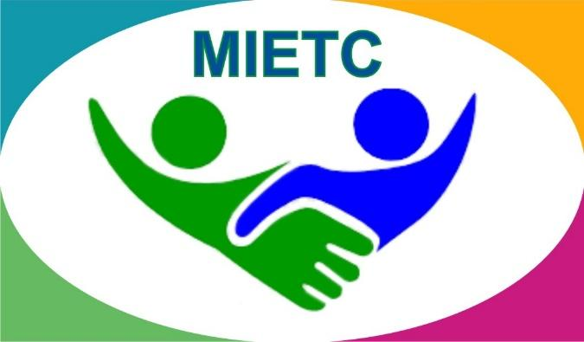
DEVELOPMENT OF A MASTER PROGRAMME IN THE MANAGEMENT OF INDUSTRIAL ENTREPRENEURSHIP FOR TRANSITION COUNTRIES
610198-EPP-1-2019-1-ES-EPPKA2-CBHE-JP

Partners :

Table of Contents
Introduction and Objectives 4
1.1 Kick-off meeting 4
1.2. Financial management and administration 5
1.3. Project internal communication and coordination 6
2.1. Development of guidelines for target group survey 7
2.2. Implementation of Workshops/Survey with stakeholders (3 per HEI) 8
2.3. Analysis of needs and competences 10
2.5. Accounting and monitoring mechanisms 18
2.6. Project's implementation plan 18
2.7. Defining MB, DB, AB, ECM 20
3.1.4. Developing of English language training programme 23
3.4.1. Sustainability strategy: Methodology 25
4.1. Quality Plan (QP) 28
5.1. Developing Dissemination Strategy 29
5.4. Website and visual identity 30
5.5. Social media and communication 32
Annex 1. Quality Assurance Tools 34
Annex 2. Training evaluation forms 35
Annex 3. Event evaluation form 36
Annex 4 P1. University of Santiago de Compostela (USC) 37

Introduction and Objectives
The Periodical Quality Assurance Report (PQAR) assesses the tasks carried out in the first year of the project implementation (M1-M18), compares the actual output with that of planned one, highlights the main problems and weaknesses, and provides recommendation on how to improve the process and expected results.

According to the Quality Assurance Plan (QAP) tasks of reported period are evaluated within the following criteria:
- Ensure consistency of the format of all the project materials.
- Ensure traceability of the actions and results.
- Identify potential problems or weaknesses with the purpose of correcting them.
- Improve the overall quality of the project results and outputs.
- Ensure long-term sustainability of the project results.

1. Project Management Evaluation

1.1 Kick-off meeting
In the scope of the MIETC project, the online Kick-off meeting took place on the 12th and 13th of March 2020. The project coordinator sent each partner a Kick-off meeting agenda. After the meeting, minutes were elaborated and uploaded to an online project repository, it is accessible to all partners.
According to the list of attendance 42 participants from 11 partner institutions participated at the on-line meeting. Number of participants from partner institutions presented in Table 1.
Table 1.1 - Number of Participants
P# | PARTNER INTUITIONS | NUMBER OF PARTICIPANTS
P1 | USC | 2
P2 | Ayeconomics, | 6
P3 | UL | 2
P4 | UNNA | 6
P5 | EKTSU | 4
P6 | AST | 2
P8 | TSIF | 1
P9 | KEUK | 6
P10 | TUT | 7
P11 | TSUC | 5
P14 | ECBP | 1

Participants from 3 partner institutions did not participate in the Kick-of meeting:
P7 – Turkmen State Institute of Economics and Management;
P12 –Centre of Technologies of Academy of Science of Turkmenistan;
P13 – Technopark FANOVAR (Tajikistan).

During the kick-off meeting, all participants actively participated in discussion of 10 partners’ presentations according to the approved agenda (all presentations are available on the online project repository). Moreover, the participants discussed the technical, financial and administrative issues; strategies concerning quality assurance, content development, management, dissemination, sustainability, entrepreneurship centres and English training.

Strength of the kick-off meeting

- Comprehensive introduction of the project management issues
- Concept of strategies were presented within respective project WPs assigned
- Usage of the project-approved template for reports and other documents
- High quality of online meeting platform
- Team coherence and reciprocity

Weaknesses
- Absence of surveys of kick-off meeting participants
- No revision of the outputs by the MB

Recommendations
- Conduct post-event surveys
- Involve MB in output revision process
- Encourage all project partners to participate in all project-related meetings

1.2. Financial management and administration
During the online kick-off meeting, the financial manager and administration from USC have thoroughly clarified the details of the Financial Management Guide (FMG) and this guide was made available on the online project repository for partners.
Partners timely report about activities carried out per 6 months. Moreover, first and second instalments for financial transfers for staff and equipment expenses for the reported period were made in Compliance with the regulatory framework except for TSUC which exceeded the allocated fund by 11% due to increase of price for equipment (see Table 2). The planned travels did not take place due to Covid-19, and for this reason the project was extended for another year.

Table 1.2 – 1st Year Consolidated Expenditure Report
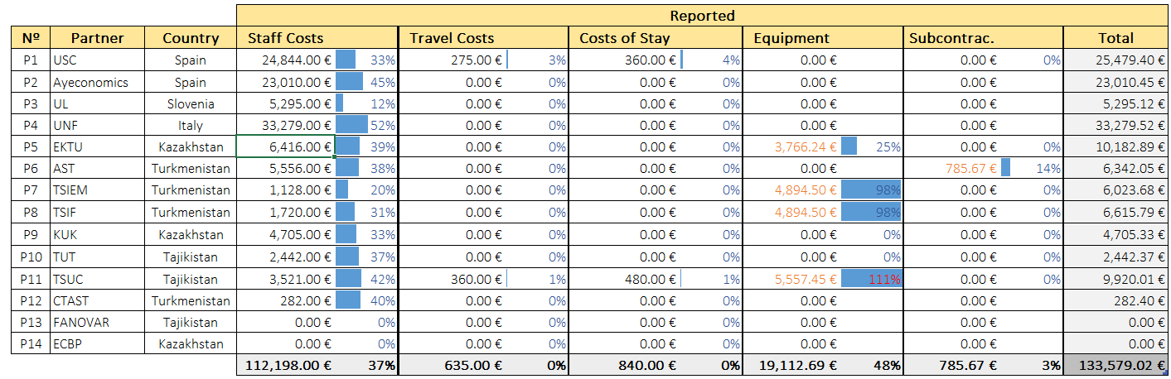
Strength
Financial management is carried out pursuant to Financial Management Guide (FMG). All project partners received two tranches and all their spending during the reported period are in line with the planned budget; except for in-person meetings.

Weaknesses:
Due to COVID-19, all the planned visits were canceled and thus the planned budget for such purposes (tickets, allowances, accommodation, etc) was frozen.
Recommendations
- For each reported period revision of the outputs should be provided by the MB
- TUT (P10) should purchase the planned equipment in accordance with the regulatory framework.

1.3. Project internal communication and coordination
Within the reported period the following outputs were achieved within the current component:
- Internal Communication and Coordination Plan consisting
    - regulatory framework
    - roles of the distributed management bodies
    - decision-making process
    - conflict resolution mechanism
    - communication tools and procedures
- Communication channels set up
- Project repository set up

Should be noted that USC developed the Internal Communication and Coordination Plan to ensure effective coordination and administration of the project. All partners were actively involved in internal communication through email, online meetings and online resource repository under the coordination of the project coordinator – USC. Furthermore, involved partners actively participated in the discussion of the following project issues:
- Finance
- Drafts of strategies
- Surveying and marketing analysis
- Labour market needs and employer participation
- Curriculum design
- Equipment purchases, etc.
Strength
Such elaborated internal communication and coordination plan helps to conduct work within the project at a good and effective level.
Effectiveness of project coordination can be confirmed through the following activities:
- Timely informing participants about the upcoming events and sharing supporting materials;
- Consultations and providing professional assistance regarding project-related issues (e.g. assisting in preparing a partner's financial documents, decision-making, etc.)
- Highly responsive to any inquiries from project partners
Recommendation
- All outputs of this component should be revised by the MB and shortcoming proposed for consideration

2. Evaluation of Project Preparation

2.1. Development of guidelines for target group survey
The Guideline for Target Group Surveys was developed by AYeconomics aimed at determining skills in shortage for the industrial sector taking into consideration all stakeholders (industry, HEIs, graduates, employees) (Picture 2.1).
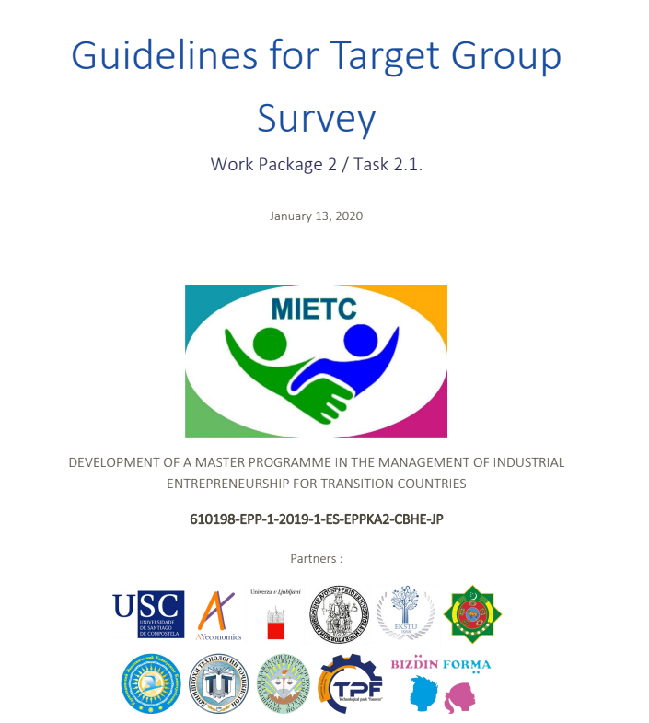
Picture 2.1 – Title page of the Guidelines
In the reported period 2 round surveys were conducted in accordance with the Guidelines which included skill needs assessment, quantitative and qualitative analysis (Delphi Analysis) of Central Asian partner labour markets.
The survey was sent to stakeholders from CA partners in Russian language, based on English version of the survey, to make it easier and more understandable. Extra skills were added based on the suggestions of experts and the results of the first round in order for the participants to come to a consensus. Since the second round of the survey was made individually for Tajikistan, the logical chain was preserved only to determine which group the experts belong to.
Strength
Surveys were professionally conducted in accordance with the Guidelines for each Target Group.
Recommendation
Survey results should be revised by the AB

2.2. Implementation of Workshops/Survey with stakeholders (3 per HEI)
In the framework of the capacity building project "Development of a Master Program in the Management of Industrial Entrepreneurship for Transition Countries" (MIETC), Delphi survey – adherent to the guidelines for the market need analysis developed within the MIETC project – was conducted to identify the skill requirements of the labour markets in each of the Central Asia countries included in the project and to adjust the contents of the master programme (Picture 2.2).
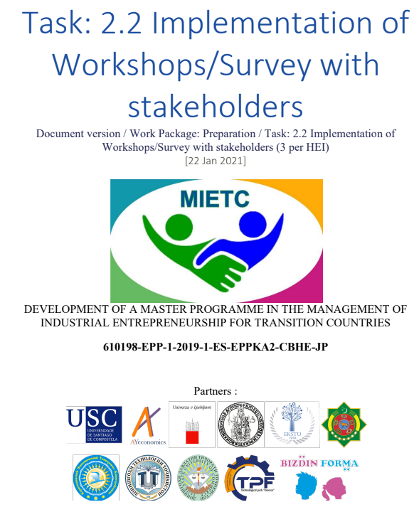
Picture 2.2 – Title Page of the Report

Table 2.1 – Response Rates to Delphi Survey
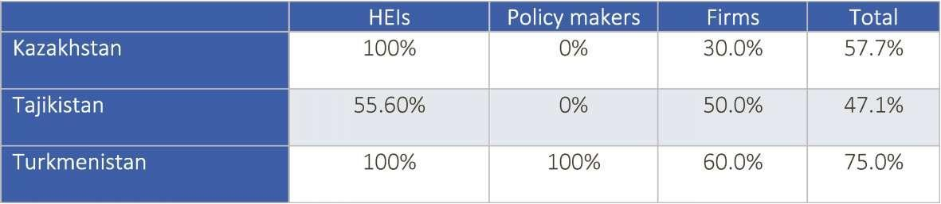
The response rate is almost 50% in Tajikistan, 58% in Kazakhstan and 60% in Turkmenistan. However, while HEIs show a high response rate, firm response rate is much lower, particularly for Kazakhstan with 30%. No replay from Policy makers from Kazakhstan and Tajikistan was received. However, it's also true that the number of policy makers in the expert list was a maximum of two per region from about 15 experts.

After the Delphi Survey results were obtained, a workshop was held to discuss them and propose policy recommendations for improvement. 15 people from 6 project partners participated in the workshop:

Table 2.2 – Workshop participants
P# | Acronym | Name
P1 | USC | Angel Duarte Campos
P2 | Ayeconomics | Aizhan Samambayeva
P2 | Ayeconomics | Iria Dios Murcia
P2 | Ayeconomics | Yolanda Pena Boquete
P2 | Ayeconomics | Alijan Artykov
P2 | Ayeconomics | Daryna Mazur
P3 | UL | Tomaz Cater
P4 | UNINA | Gerardo Carpentieri
P4 | UNINA | Floriana Zucaro
P4 | UNINA | Carmen Guida
P6 | AST | Prof. Dr. Charyyar Amansahedov
P6 | AST | Rustam Gadzhiyev
P6 | AST | Ruben Yegoshin
P7 | TSIEM | Chary Shallyyev (by phone)  4 students of 1,2, and 4-th grade  Kerim Cherkezov, Aygul Atdyeva, Selbi Toyliyeva, Aman Nepesov
P8 | TSIF | Shohrat Byashimov (by phone)

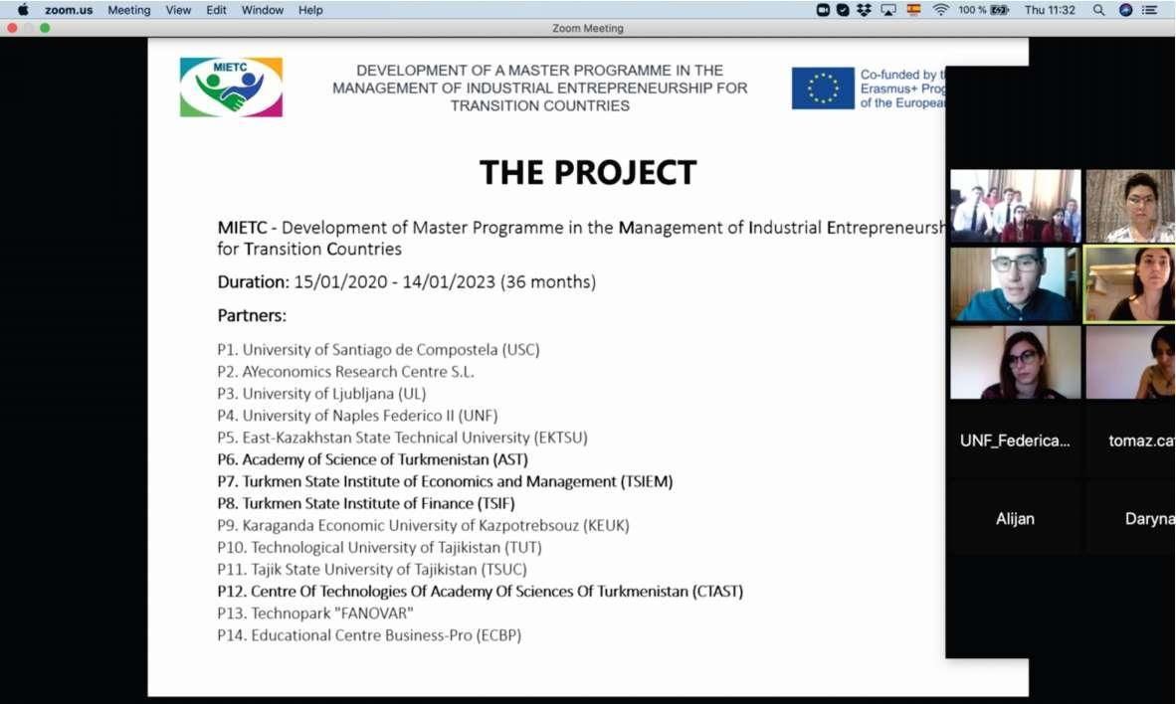
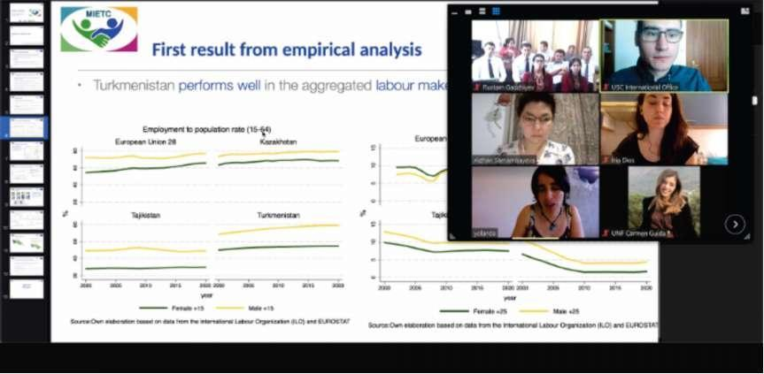
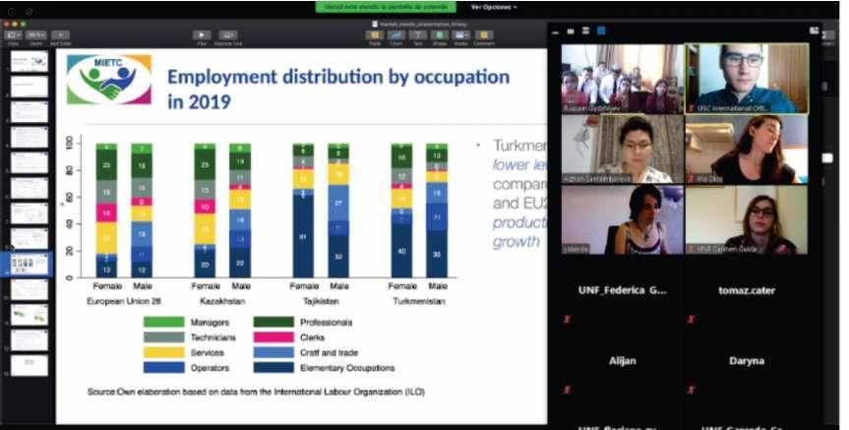

2.3. Analysis of needs and competences
Market Needs Analysis
According to the plan in the reported period an extensive market needs analysis was carried out with an aim to identify skills shortages and mismatch in Central Asian countries, specifically, Kazakhstan, Tajikistan and Turkmenistan. The European Union average is taken as a benchmark for comparison reasons. Moreover, this report is aimed to shed light on the skills shortage and uncover causes of market underperformance (Picture 2.3).

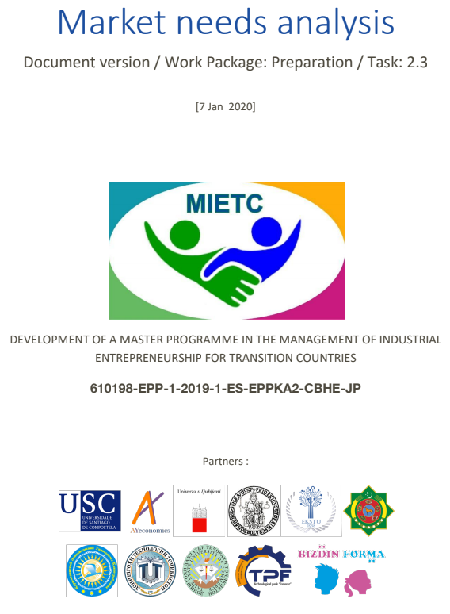
Picture 2.3 – Title Page of the Report

The report starts with broad analysis of macroeconomic and labour market indicators to have a general picture of economic performance of observed countries. Then, the analysis is narrowed down to the deeper regional analysis of the labour market within each country discovering interregional disparities and skills shortage in some regions caused by low labour mobility. The next level of research identifies skills needed at the firm level and specifies the type of skills by type of firm. Finally, research provides trends and forecasts that will affect the future skills demand. Conclusion is in the final chapter of the document.

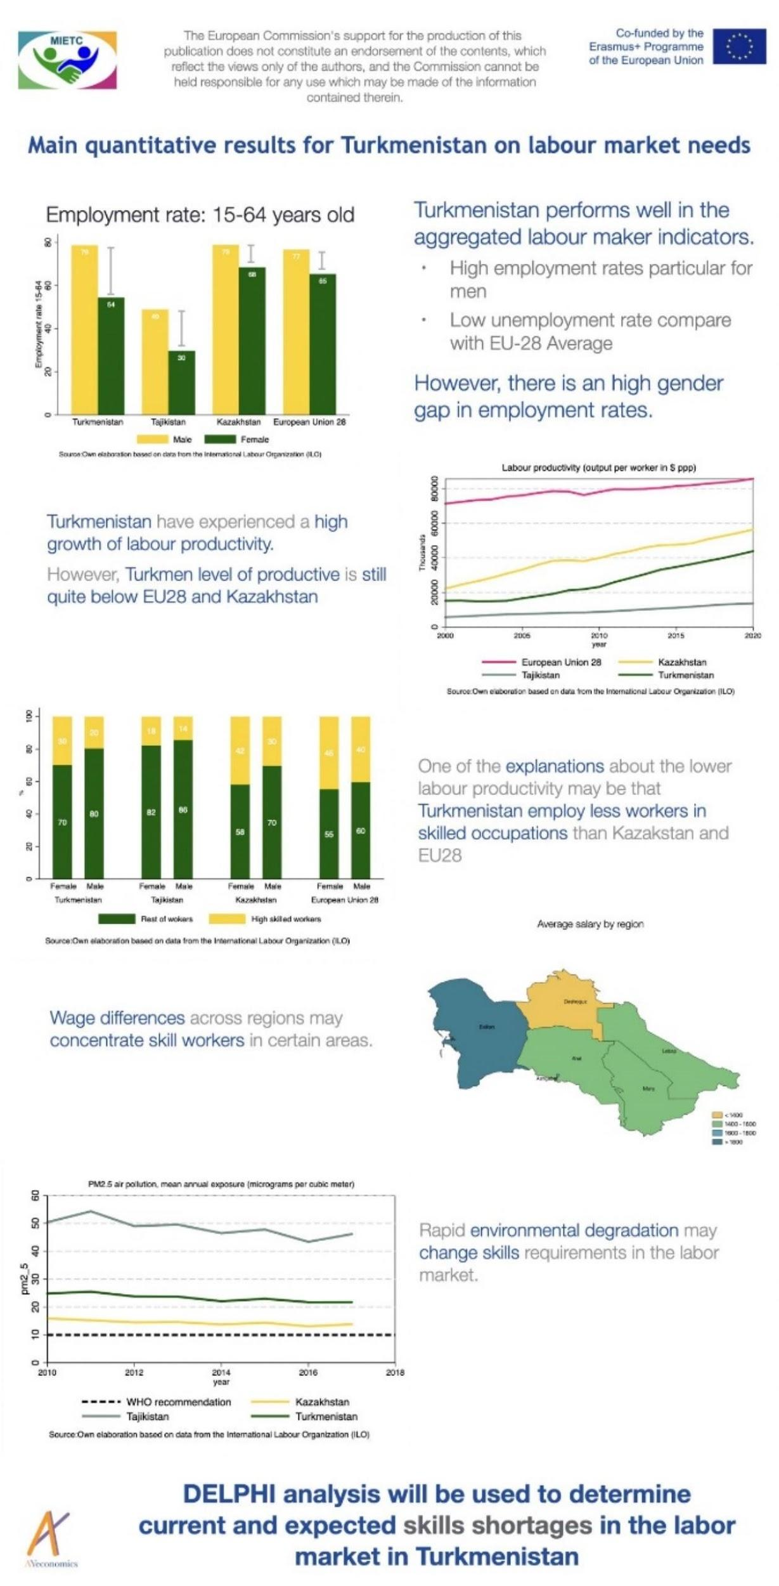
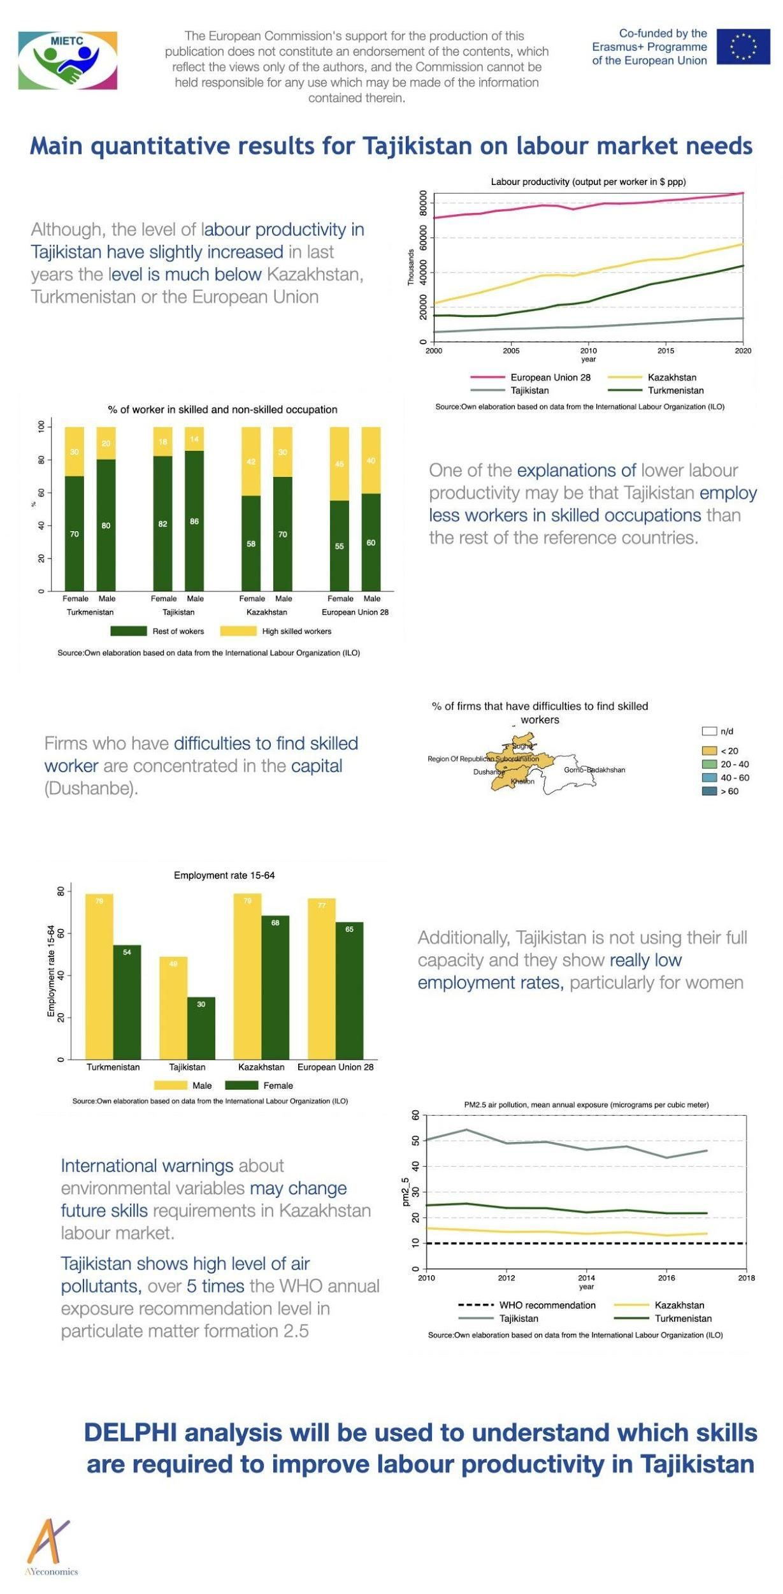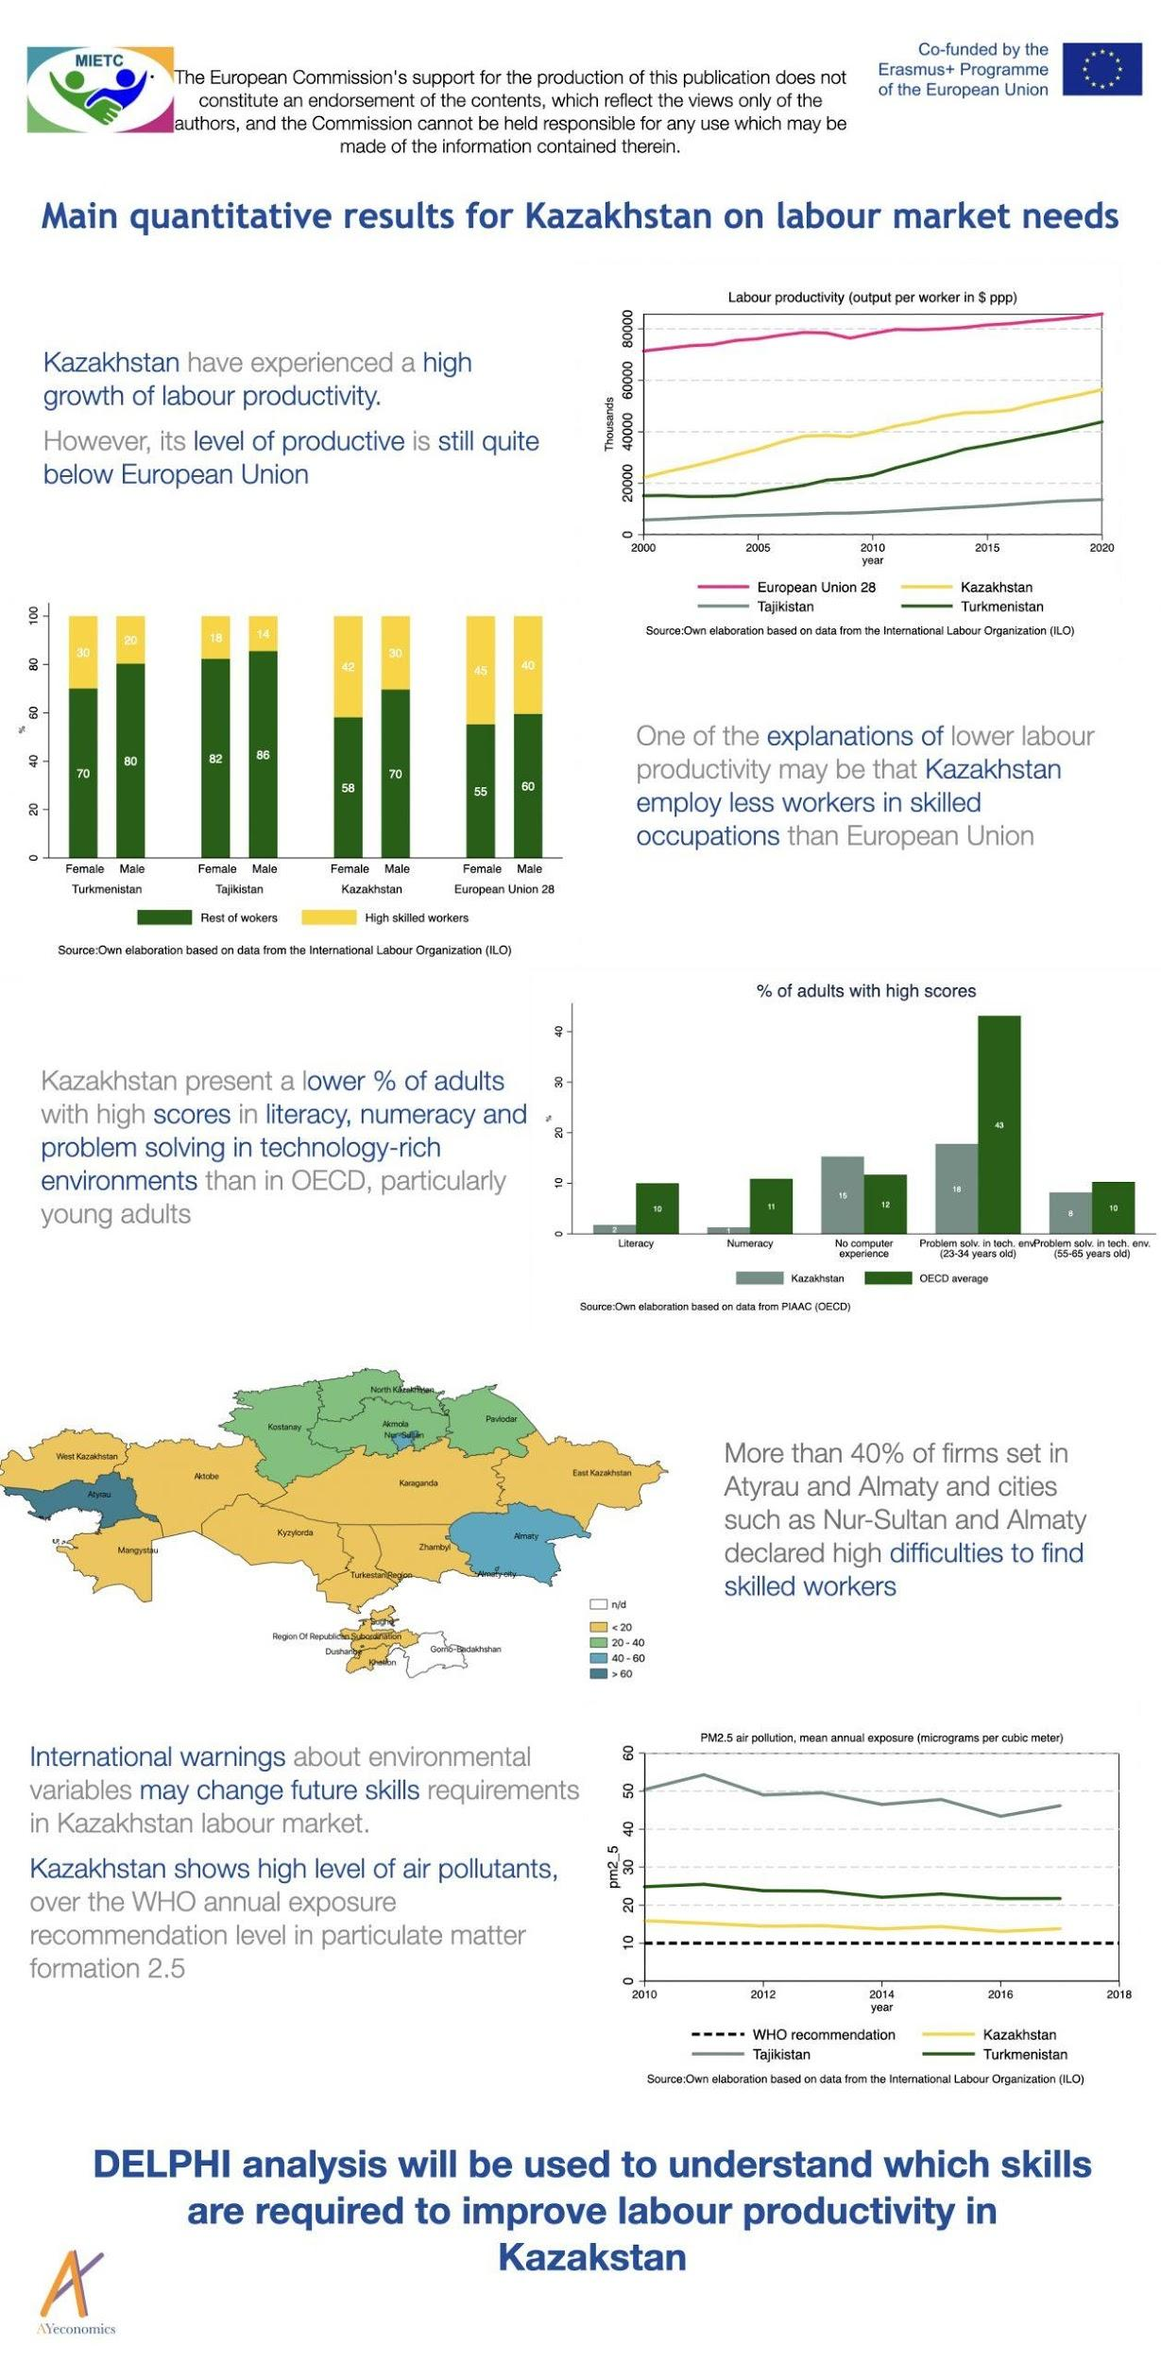

Competence analysis
According to the analysis carried out with the partner universities in Central Asia, the following conclusions could be drawn:
The average age of students is less than 25 years old, that is, immediately after the completion of the bachelor's program. Consequently, most of the students have no work experience.
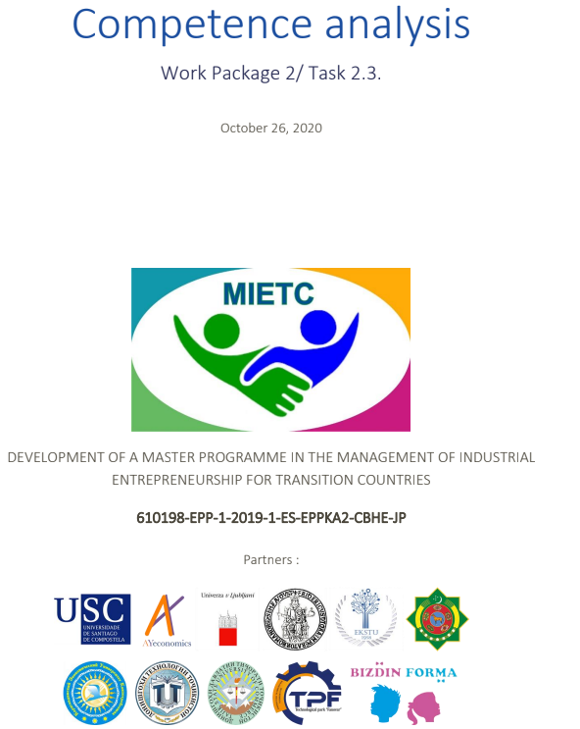
Picture 2.4 – Title Page of Competence Analysis

The number of students in groups varies and reaches from 20 to 60 students per group. The ratio of students by gender in similar industrial programs is almost the same in Kazakhstan and Turkmenistan, while in Tajikistan male students outnumber female students and make up 70%. Students of the Master's program participate in the full-time program. According to the share of foreign students, they are present only at the university of Kazakhstan (EKTSU), accounting for only 2%.
Below is a table showing the number of students accepted, graduated in 2018-2020 years, as well as the mode of study and its conditions and a gender split.

Table 2.3 – Students competence analysis summary
Countries | Accepted students at master level in previous year | Students expected for the master | Expected students background | Mode of study | Gender split
KZ - EKSTU | 432 | 20 | Engineering, Economics | Full-time (with the opportunity to work) | F-45,2%  M-54,8%
TKM - TSIEM | 60 | 20 | Business,  Economics,  Management | Full-time (mainly) | F-48%  M-52%
TKM - TSIF | Do not have master program | 20-40 | Currently no undergraduate degree | Full-time (will  deal with nonworking students) | F-57%  M-43%
TJ - TUT | 157 | 10-25 | No info (mainly applied for Economics) | Full-time (not  entitled to work) | F-30%  M-70%

Teachers Competence analysis
EKSTU
According to the data provided by the EKSTU, the majority of teachers in this university specialise in Management and Data. There are also several professors teaching Business and Engineering.
The total number of professors is 15.
AST
In AST, all professors with background in technical specialisation and none in business. There are 2 professors specialising in Engineering, 2 in ICT in economy and 1 in Social Economy.
The total number of professors is 5.
TSIEM
At this university, most of the professors specialise in various areas of Business Management and Economics. There are 4 professors teaching the Information system.
The total number of professors is 22.
TSIF
At TSIF University almost all professors have Finance as a field of expertise. This university has 2 professors specialising in Management, 1 in financial mathematics and 22 financiers.
The total number of professors is 25.
KEUK
At this university the main fields of expertise of professors are Economics, Public Administration and Management.
The total number of professors is 21.
TUT
In this university, the majority of professors have a background in Statistics, IT, International Economics, Financial Market and other fields.
The total number of professors is 19.
TSUC
The professors of this university specialise in Banking and Management, Marketing and Entrepreneurship, Business planning and other related subjects.
The total number of professors is 21.

Table 2.4 –Level of English of the professors
 | EKSTU | AST | TSIEM | TSIF | KEUK | TUT | TSUC
A1 | 0 | 0 | 12 | 14 | 8 | 0 | 0
A2 | 1 | 0 | 8 | 8 | 0 | 8 | 7
B1 | 3 | 5 | 1 | 3 | 8 | 9 | 8
B2 | 8 | 0 | 1 | 0 | 5 | 2 | 6
C1 | 3 | 0 | 0 | 0 | 0 | 0 | 0
Total: | 15 | 5 | 22 | 25 | 21 | 19 | 21

Figure 2.1 – Percentage of professors by English level
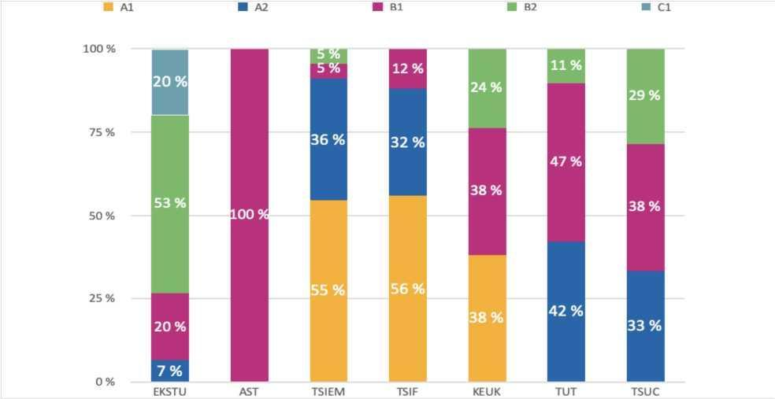
From the chart we can see that at EKSTU all of the professors have levels B1 and higher. At AST all of the professors are B1 in English.
At TSIEM and TSIF Universities most of the professors have A1-A2 levels.
KEUK has professors with A1, B1 and B2 levels.
At TUT and TSUC Universities all of the professors have levels B1 and higher.

Overall, in the reported period, such aspects as lacking skills in the market, macroeconomic and labour market indicators, regional analysis of the labour market trends and forecasts of future skills demand are thoroughly analysed.

2.5. Accounting and monitoring mechanisms
For the reported period, budget expenditure reports were prepared and main achieved indicators were highlighted. All reports and activities were carried out in conformity with all levels of regulation
Table 2.5 – Total Grant Awarded and Break Up of Expenses for The Reported Period
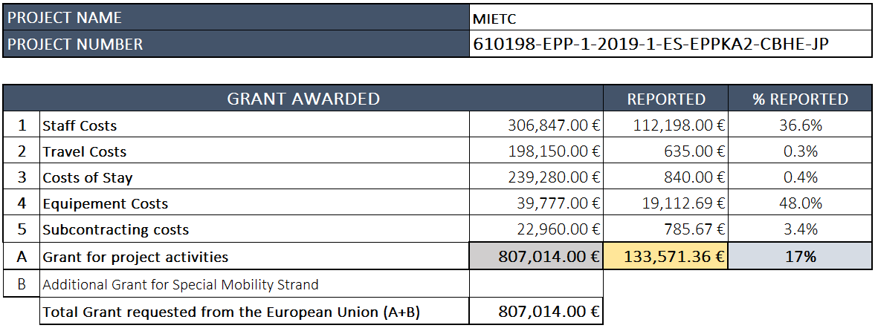
Out of the total grant awarded 133,571,36 Euro was spent for the reported period, which is equal to 16.55 percent of the grant.

2.6. Project's implementation plan
In accordance with the plan the roles and general and specific responsibilities of Management Board (MB), Dissemination Board (DB), Academic Board (AB), Entrepreneurship Centre Manager Entrepreneurship Centre Manager (ECM), and Task Core Groups (TCGs) were defined and tasks assigned to each respective board and project partner represented in the board (Picture 2.5).
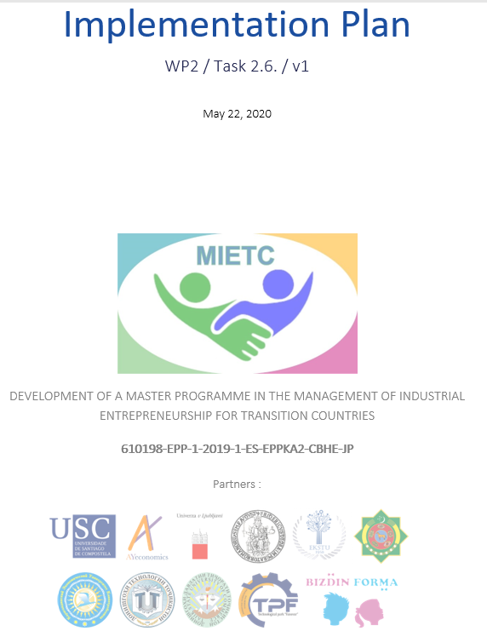
Picture 2.5 – Title Page of Implementation Plan

The project workload was organized in five following work packages (WP) which ensures effective management and timely implementation of the projects.
WP1: Management.
The management structure will efficiently address the specific objectives via a clear distribution of tasks and authorities and achieve an effective administrative management. All partners will be engaged in the management activities.
WP2: Preparation. The primary objectives of this work package is detailed market needs analysis through the use of Delphi analysis which will include primary research (focus groups, surveys and etc), competitive analysis and secondary research (statistics, articles, newspaper etc). The competence analysis will help to adapt training and learning material to the competence level of teachers.
WP3: Development. The objective of this Work Package is to engage the participating HEIs, Research Institutes, Technoparks, Entrepreneurs and Policy makers into the co-design of the project´s curriculum and study materials ensuring its relevance to the market.
WP4: Quality Assurance. The Quality assurance procedure will ensure that all the project’s activities, outputs and deliverables comply with the overall objectives of the project and the specific objectives of each Work Package (WP). All project activities will be subject to a Quality Assurance procedure in order to ensure conformity with the objectives and results as they are foreseen in the project contract. Partners will support the work of the WP with regular information provision and taking corrective actions, if needed
WP5: Dissemination. The work package on dissemination and exploitation aims at establishing the Project´s brand, to raise awareness among industrial companies, students, policy makers and other HEIs. To this end, the WP is key to the project’s success. WP will ensure optimised project results, large-scale impact and sustainability during and after project lifecycle and will go beyond partner organisations and countries to a wider range of public all over Europe CA countries.

Strength
The Implement Plan is well and thoroughly developed and enable best and effective implementation of the project.

2.7. Defining MB, DB, AB, ECM
Within the project MB, DB, AB, ECM were defined and with following representatives from each partner of the project
Management Board (MB)
P# | Acronym |  | Country | Name | Email | Telephone
P1 | USC |  | Spain | Anne Forryan | international.projects@usc.es | (0034) 881812878
P2 | AYeconomics |  | Spain | Aizhan Samambayeva | a.samambayeva@ayeconomics.com | 0034 981111076 / 0034 672240547
P3 | UL |  | Slovenia | Mojca Maher Pirc | mojca.maher.pirc@ef.uni-lj.si | 38615892805
P4 | UNINA |  | Italy | Carmela Gargiulo & Floriana Zucaro | lilli.gargiulo1@gmail.com; floriana.zucaro@unina.it | 0039 3334874379
P5 | EKTSU |  | Kazakhstan | Zhadyra Konurbayeva | kzhadyra@yandex.kz | 0077 771827250
P6 | AST |  | Turkmenistan | Rustam Gadzhiyev | rustamtme@gmail.com | 00993 65560720
P7 | TSIEM |  | Turkmenistan | Charymuhammet Shallyyev | charysha@mail.com | 00993 65804536
P8 | TSIF |  | Turkmenistan | Shohrat Bashimov | byashimov.1985@mail.ru | 00993 65017485
P9 | KEUK |  | Kazakhstan | Oxana Bezler | bezleroxana@mail.ru | 007 7016773576
P10 | TUT |  | Tajikistan | Ahror Jafarov | ahrorjafarov@gmail.com | 00992 901223315
P11 | TSUC |  | Tajikistan | Zarrina Kadyrova | zarinkadirova@gmail.com | 00992 372348434 / 00992 935074595
P12 | CTAST |  | Turkmenistan | Ahmed Akmammedov | technopark.tkm@gmail.com | 00993 65560720
P13 | FANOVAR |  | Tajikistan | Muzafar Rahimov | mrahimov24@gmail.com | 00992 907337888
P14 | ECBP |  | Kazakhstan | Zhanargul Kulmagambetova | zhanargulkul@gmail.com | 007 7758502466
Academic Board (AB)
P# |  | Acronym | Country | Name | Email | Telephone
P1 |  | USC | Spain | Manuel Fernández Grela | mf.grela@usc.es | 0034 881811534
P2 |  | AYeconomics | Spain | Yolanda Pena Boquete | y.penaboquete@ayeconomics.com | (0034) 981111076 / (0034) 672240547
P3 |  | UL | Slovenia | Tomaz Cater | tomaz.cater@ef.uni-lj.si
P4 |  | UNINA | Italy | Gerardo Carpentieri | gerardo.carpentieri@unina.it | 0039 33452428562
P5 |  | EKTSU | Kazakhstan | Elvira Madiyarova | emadiyarova@mail.ru | 007 7762800004
P6 |  | AST | Turkmenistan | Charyyar Amansahedov | amansakhatov@yandex.ru | 00993 12943091
P7 |  | TSIEM | Turkmenistan | Nurmammet Altyyev | serdarow90@mail.ru | 00993 65558179
P8 |  | TSIF | Turkmenistan | Nuryagdy Aynazarov | naynazarow@yandex.ru | 00993 65623735
P9 |  | KEUK | Kazakhstan | Ainura Omarova | ainuraphd@mail.ru | 007 7781088696
P10 |  | TUT | Tajikistan | Abdurasul Sattorov | s_rasul3131@mail.ru | 00992 918133131
P11 |  | TSUC | Tajikistan | Mubinzhon Abduvaliev | mubin104@gmail.com | 00992 372348434 / 00992 938360700
P12 |  | CTAST | Turkmenistan | Durdy Atayev | technopark.tkm@gmail.com | 00993 65570084
P13 |  | FANOVAR | Tajikistan
P14 |  | ECBP | Kazakhstan
Dissemination Board (DB)
P# |  | Acronym | Country | Name | Email | Telephone
P1 |  | USC | Spain | Lucía Barreiro Valladares | international.pr@usc.es | 0034 881811139
P2 |  | AYeconomics | Spain | Iria Dios Murcia | iriadiosm@ayeconomics.com | 0034 672240547
P3 |  | UL | Slovenia | Klavdija Besednjak
P4 |  | UNINA | Italy | Federica Gaglione and Carmen Guida | federica.gaglione@unina.it; carmen.guida@unina.it | 0039 26228986
P5 |  | EKTSU | Kazakhstan | Madina Yussubaliyeva | yumadina@mail.ru | 007 7772645150
P6 |  | AST | Turkmenistan | Rustam Gadzhiyev | rustamtme@gmail.com | 99365560720
P7 |  | TSIEM | Turkmenistan | Charymuhammet Shallyyev | charysha@mail.com | 00993 65804536
P8 |  | TSIF | Turkmenistan | Shohrat Bashimov | byashimov.1985@mail.ru | 00993 65017485
P9 |  | KEUK | Kazakhstan | Olessya Zhidkoblinova | olesya.zhidkoblinova@mail.ru | 007 7712636143
P10 |  | TUT | Tajikistan | Tahmina Rabieva | tahminatd@mail.ru | 00992 918657617
P11 |  | TSUC | Tajikistan | Abdullozoda Nurmuhammadi | abdullozoda.n@gmail.com | 00992 372348434 / 00992 988288000
P12 |  | CTAST | Turkmenistan | Shirmuhammet Ovekov |  | 00993 61870620
P13 |  | FANOVAR | Tajikistan | Yaminzoda Zarina | zyaminova@inbox.ru | 00992 900281085
P14 |  | ECBP | Kazakhstan | Zhanargul Kulmagambetova | zhanargulkul@gmail.com | 007 7758502466
Entrepreneurship Centre Manager (ECM)
P# |  | Acronym | Country | Name | Email | Telephone
P1 |  | USC | Spain
P2 |  | AYeconomics | Spain | Aizhan Samambayeva | a.samambayeva@ayeconomics.com | 0034 981111076 / 0034 672240547
P3 |  | UL | Slovenia
P4 |  | UNINA | Italy
P5 |  | EKTSU | Kazakhstan | Marina Kozlova | mara_koz@mail.ru | 0077 054194582
P6 |  | AST | Turkmenistan | Ahmed Akmammedov |  | 00993 12943051
P7 |  | TSIEM | Turkmenistan | Bashim Ivanov | bashim_im@mail.ru | 00993 65099566
P8 |  | TSIF | Turkmenistan | Kerim Muhammedov | kerim1387@mail.ru | 00993 65567387
P9 |  | KEUK | Kazakhstan | Yelena Stavbunik | sea826@yandex.kz | 007 7014027493
P10 |  | TUT | Tajikistan | Nurali Avgonov | avgonov.nurali@mail.ru | 00992 934401212
P11 |  | TSUC | Tajikistan | Muhammadali Eshov | mr.eshov@gmail.com | 00992 372348434 / 00992 900044477
P12 |  | CTAST | Turkmenistan | Ahal Gurbaniyazov | technopark.tkm@gmail.com | 00993 65809217
P13 |  | FANOVAR | Tajikistan | Muzafar Rahimov | mrahimov24@gmail.com | 00992 907337888
P14 |  | ECBP | Kazakhstan | Zhanargul Kulmagambetova | zhanargulkul@gmail.com | 007 7758502466

Strength
Appointment of responsible people at MB, DB, AB, ECM from each partner institution will enhance the efficiency and effective implementation and management of the project.
Recommendation
Representatives at AB from FANOVAR (P13, Tajikistan) and ECBP (P14, Kazakhstan) are missing. Therefore, it is recommended to add information.

3. Curriculum design and Project Sustainability

3.1.4. Developing of English language training programme
English language training programme was developed and being implemented by EKSTU aimed at improving the English language proficiency of academic staff B2 level to empower teaching staff of Central Asian partner universities to use English as the language of instruction. To train English courses a specific plan will be worked out by EKSTU. EKSTU is responsible for providing an English course for all partners, ensuring that until the start of training, all partners will have a minimum B2 level of English (Picture 3.1).

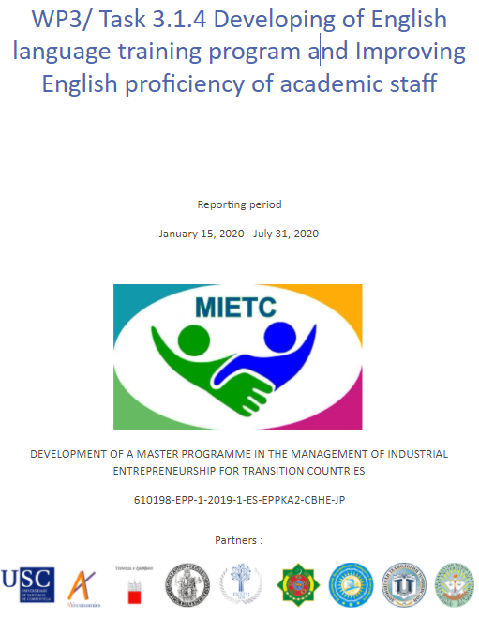
Picture 3.1 – Title Page of English Language Training Programme
The University has developed the English language training strategy outlining timeframe and activities. 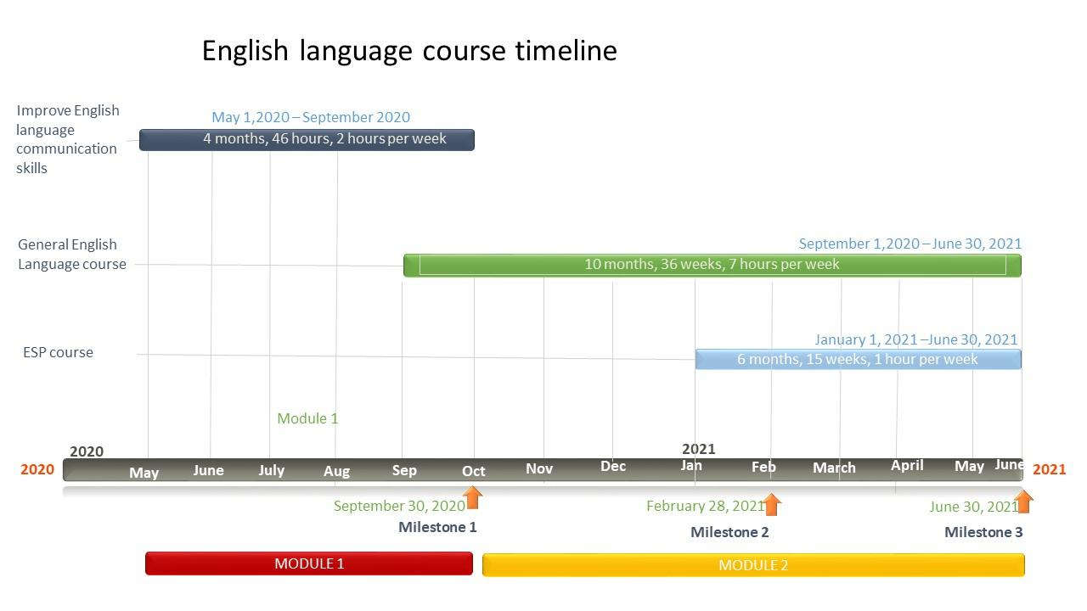
It is expected that 129 teachers from CA partner universities will master English at a level of at least B2 to teach their subject in English, confirmed by certificates from Edusoft ETSl, Coursera, EKSTU and optionally TOEFL ITP. The teacher will be able to:
- Read and understand authentic academic texts on management, marketing, finance and data analysis.
- Use academic vocabulary in the area of ​​professional knowledge.
- Create text for academic lecture presentations
- Communicate in English for successful professional interaction
- Write emails, speak at meetings, give presentations and communicate in the field of professional communication.
The English training programme consists of three modules each focused on mastering specific skills of English language and they will be completed by the implementation stage of the project in CA universities in 2022.
The first module is focused on improving English communication skills. The course helps to improve professional communication in English for successful interactions. It focuses on a particular area of communication in English. By the end of the course trainees will be able to write emails, speak at meetings and interviews, give presentations, and network online. Trainees will earn certificates.
The second module will focus on General English language training through an interactive multimedia online course with English Discoveries. This will have a total duration of 36 weeks spanning over 10 months. Trainees will take a placement test and the number of hours devoted per week will depend on their English level. Progress will be measured and evaluated through a series of indicators (tests, e-surveys, completion of activities, etc.). EKSTU will develop a study plan and will tutor and orient the students.

Moreover, the second module will focus on improving teachers’ academic English EKSTU develops an ESP course to empower teachers of Management, Marketing, Finance and Data Analysis to use English as a medium of Instruction. This will be implemented using the Authoring tool in English Discoveries and will have a total duration of 10 weeks. The training activities of the course have been developed with the objective of adapting the learning process to the different abilities, needs and interests of the trainees.
Strength
EKSTU outlines the challenges which needs to be addressed and resolved as soon as possible
Weaknesses
Teachers are not participating in English courses which might affect the teaching quality of master programme
Recommendations
Provide in-person interactive English languages courses with local native speakers

3.4.1. Sustainability strategy: Methodology
The Tajik State University of Commerce (P11, Tajikistan) has developed the MEITC project’s Sustainability Strategy (SS) which will provide guidance and roadmap for methodology, implementation and long-term project sustainability leveraging the potential, resources, experience of project partners and external stakeholders. The Sustainability Strategy will be carried out along with other activities stated and planned within the WP 3 (Picture 3.2).

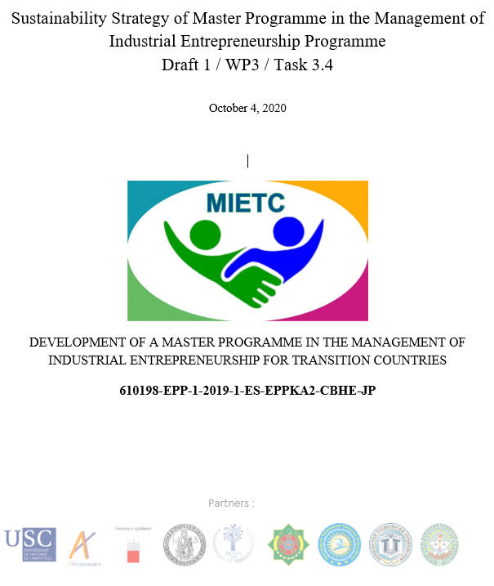
Picture 3.2 – Title Page of the Sustainability Strategy

The main objective of the Sustainability Strategy encompasses a variety of activities which will ensure a long-term success of the implemented Master Program within the MEITC project.
Action plan within the Sustainability strategy is being developed based on the following methodology:

Sustainability Strategy of Master Programme

Finding diversification

Communication and partnership

Evaluation Innovation Modernization

Recruitment Prosses & PR
Sustainability Assurance Activity Matrix
Sustainable Outcomes | Strategy to ensure their sustainability | Resources necessary to achieve this | Where will these resources be obtained?
Number of Applicants | Promotion and dissemination of materials about the Master Programme | Recruitment team (Department staff, volunteers, Alumni)  Promotion materials (leaflets, brochures, promotional gifts, etc)  Staff cost | University fund  Co-funding
Number of students in Master programme | Employment possibilities  Moderns teaching methodology  Internship opportunities  Well -designed Master Programme | Student mobility programmes  Visiting lecturers  Guest speakers/industrial experts  Access to the prestigious libraries  Professional staff  Staff cost | University fund  Co-funding
Established Network | Attract sponsorship and create a network of MIETC “supporters” | Organisation costs  Staff cost | University fund  Co-funding
Expanding events | Expanding the Academy events to more cities and countries by expanding the consortium and cooperating with academic institutions and industry in the respective countries. | Staff costs  Organisation costs | University fund  Co-funding
Co-organisation of activities and events | Co-organise the events with other major events, thus, achieving mutual benefits and networking. | Staff costs  Organisation costs | University fund  Co-funding
Diversify training | Expanding the themes of the training programme and renewing them in a regular basis. | Staff costs  Organisation costs | University fund  Co-funding

Strength
The SS specifies the steps which will be taken to ensure sustainability of the project, as well as the Sustainability Assurance Activity Matrix which should be followed to achieve sustainability.
Weakness
CA project partners are inactive in developing their own SS tailored for their own needs and unique socio-economic environment.
Recommendation
Revision of outputs by the AB & the MB.

4. Evaluation of QAP

4.1. Quality Plan (QP)

The Quality Plan was prepared within the WP 4 and encompasses Internal and External Quality Assurance processes, instruments and resources to ensure adherence to a set of quality standards that will be defined for task and output.
Based on the QP the quality of project results and outputs will greatly depend on the efficiency of the management of all aspects of the project. For this purpose, the Consortium has already set up a bundle of plans and resources.

Streamlined project management are:
- Internal Communication and Coordination Plan
- Implementation Plan
- Financial Management Guide
- Dissemination Plan
- Sustainability Strategy.
Within the QAP following the Quality Assurance Tools were elaborated:
- Guidelines for online publication
- Formats and templates for deliverables and reports produced in the project.
- Accreditation and Certification questionnaire
- Training evaluation forms
- Event evaluation form.

Recommendation
In order to monitor the conformity of the project results with standards and indicators of QAP, the Partners should conduct continuous monitoring. Based on monitoring outcomes, responsible partners prepare periodical reports identifying potential shortcomings and proposing ways to address them.
MB should:
- be proactive in overseeing the quality of the project implementation
- eliminate project discrepancy
- help to balance conflicting priorities
- make amendments where necessary
- provide insight on long-term strategies

Project coordinator (USC) has to:
- assist in conducting a survey among partners in order to evaluate activities using approved event evaluation form
5. Evaluation of Dissemination

5.1. Developing Dissemination Strategy
MEITC Dissemination Strategy provides guidance and direction for project partner’s communication with internal and external audiences. It covers WP5 activities and has a strong link to the project planned activities. The strategy emphasizes the importance of dissemination to promote the MEITS project activities and expand the project results and outcomes to a multitude of audiences. It describes the objectives, planned target groups and channels as well as indicators to measure the performance of the project’ planned activities. Monitoring throughout the project live will continuously improve the strategy. Dissemination strategy was developed by AST (P6, Turkmenistan) and it includes a very well thought out set of steps and strategies to enhance visibility of activities and sustainability throughout the implementation stage.
The document defines and outlines the following in accordance with project template and timeframe, and in compliance with EU visibility requirements:
- target audiences, dissemination methods and media
- timing of the dissemination activities
- guidance on positioning the project
- dissemination tools
- milestones and measurable indicators
- dissemination timeline and work plan
- Description of the role of each partner
- monitoring mechanisms
- Use of project templates and

Weaknesses
DS documents contains some technical error

Recommendation
DS documents needs to be proofread and outputs revised by the DB and MB

5.4. Website and visual identity
The project has a website
http://www.mietc.unina.it/
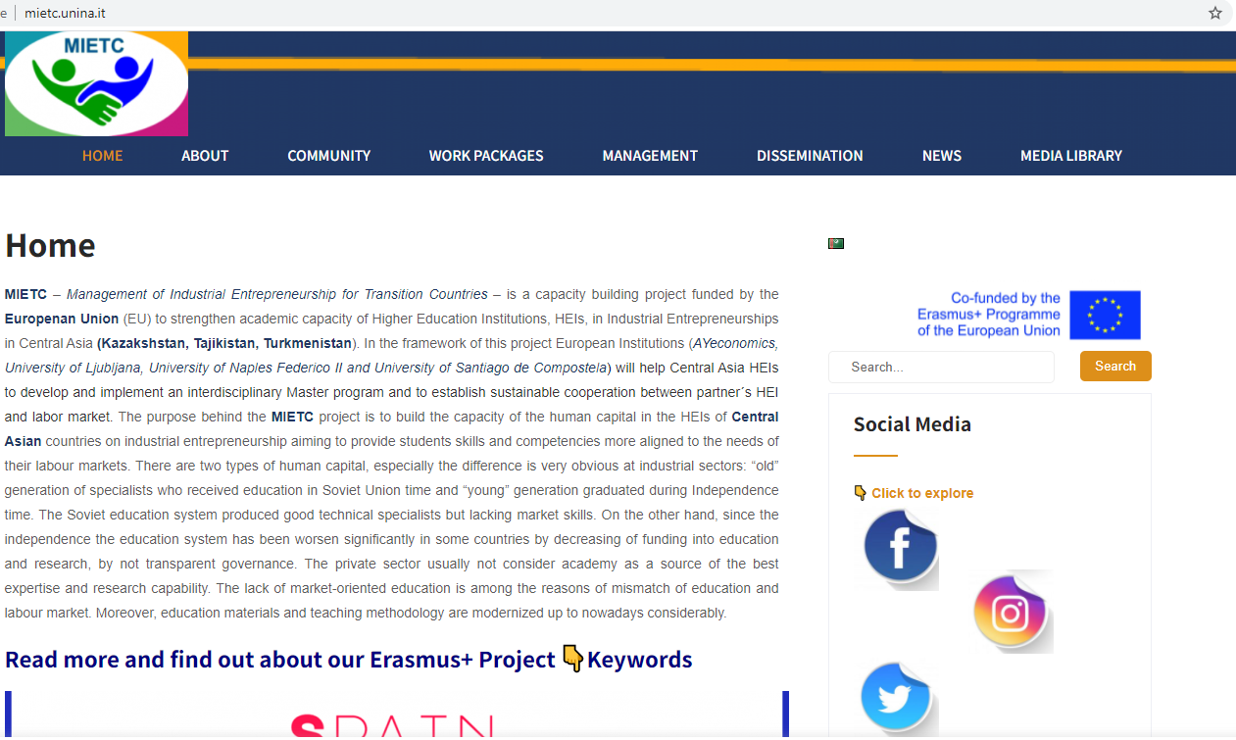

There have been held 9 events in the framework of the project and they are all post in the Dissemination section of the project website (see http://www.mietc.unina.it/index.php/events/).

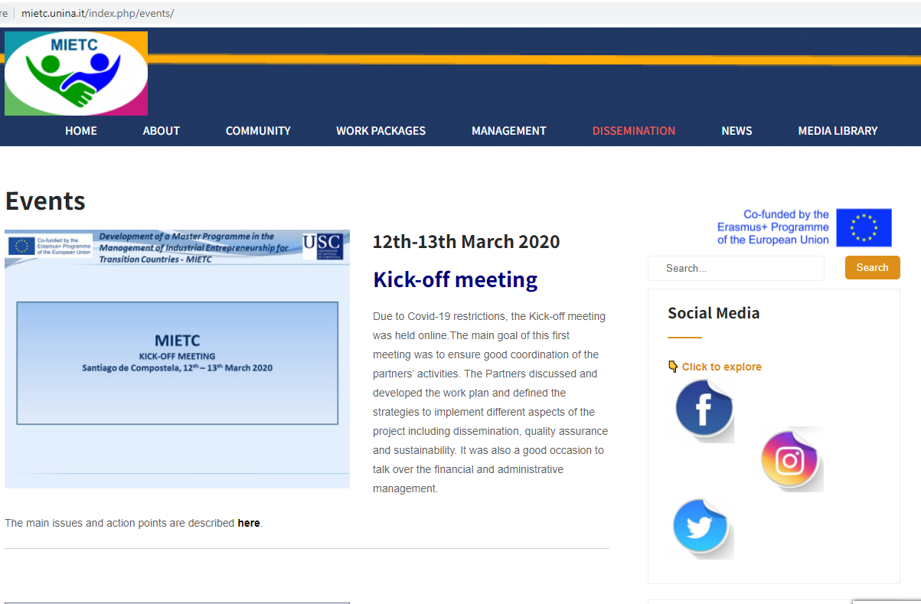

Moreover, all promotion and dissemination activities carried out by project partners are regularly posted on the website (see http://www.mietc.unina.it/index.php/products/)

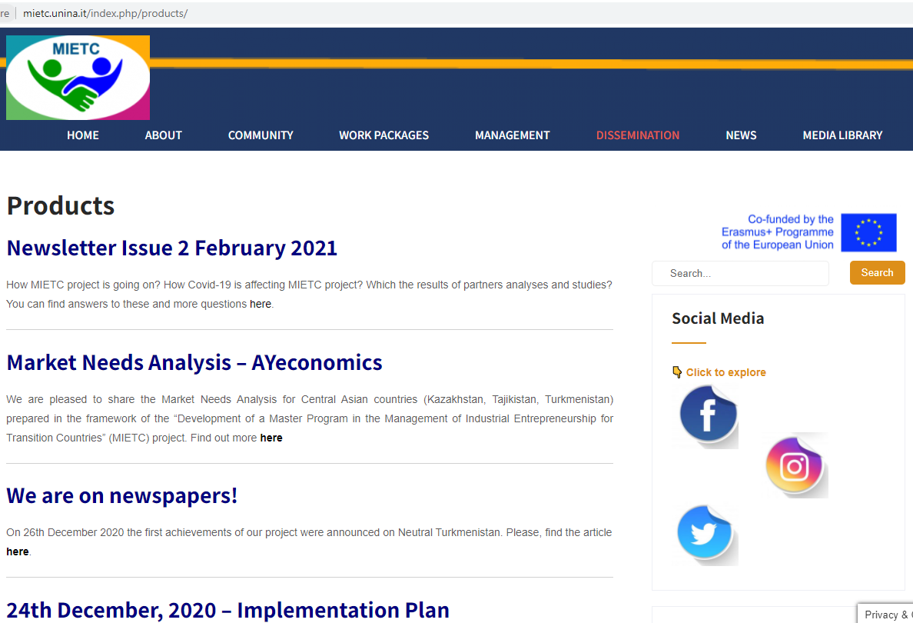

The project logo was jointly created by partners and it provided visibility, symbolism, association and unity spirit, clear ambition and pride for partners involved in the project.
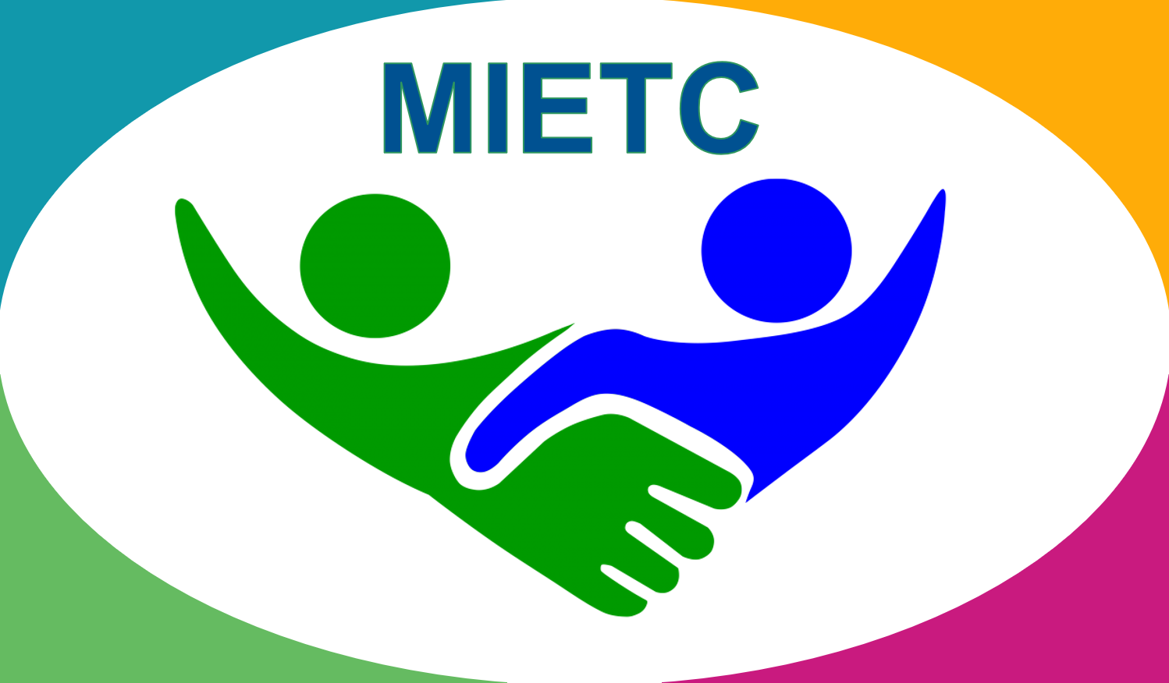

The main content of the website is available only in English.

Recommendation

According to the plan information must be available in languages of CA partner languages including in Russian. It is recommended to publish information at least in Russian for now.

5.5. Social media and communication
In the framework of the Dissemination Strategy, the official accounts were set up on popular social media. These accounts will be used to disseminate as well as to promote the project. The project is present on social media such as Facebook (https://www.facebook.com/mietcerasmusplus)
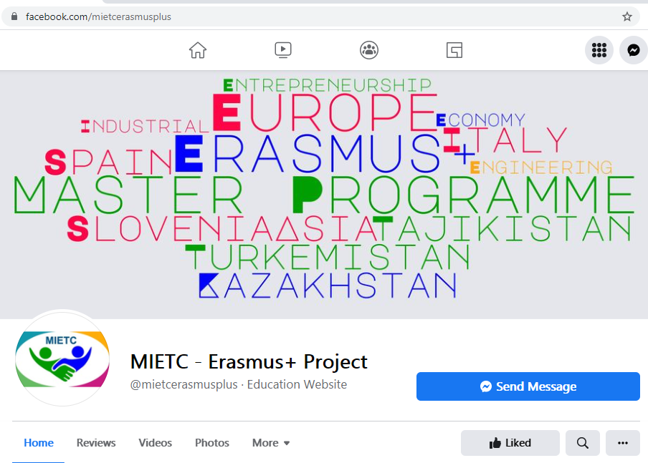
Tweeter (https://twitter.com/ErasmusMietc)
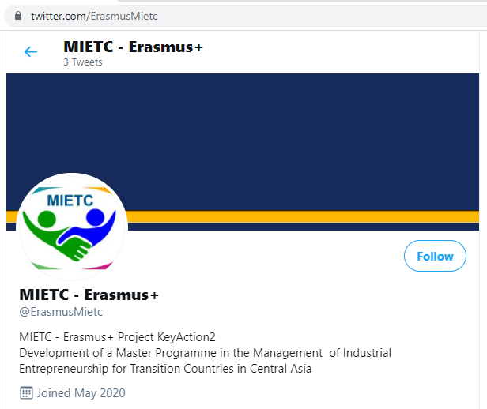

And Instagram (https://www.instagram.com/mietc_erasmusplus/?hl=it)
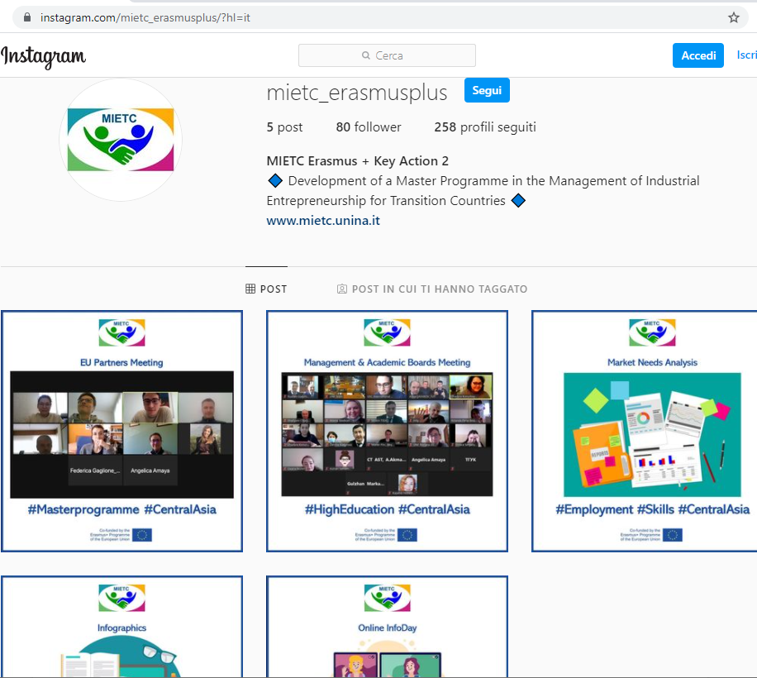

ANNEXES

Annex 1. Quality Assurance Tools

Guidelines for online publication
All the publications must be respectful of copyright and data privacy regulations of the EU and of all the countries involved in the project.
All the content published in the frame of the project must be original. Where external sources or materials are used, these must be adequately referenced. The information taken from exiting sources or gathered through surveys/questionnaires/interviews must be clearly marked, correctly attributed and, if relevant, the source material must be referenced.
When using existing data or information, permission must be obtained from the original publisher, unless it is made available under a specific license, in which case the terms said license must be strictly respected.
It is essential that all data used is accurate and representative.
Explicit permission must be obtained for the publication of photos where people are identifiable. This is of particular importance when the people featured in a photo are external to the project.

Formats and templates for deliverables and reports produced in the project.
A set of templates have been produced for deliverables, reports, presentations and other documents produced in the frame of the project. These templates are available in the project’s online repository. The use of these templates is mandatory.

Accreditation and Certification
Information about the accreditation and certification process in each country will be collected through and structured questionnaire that will allow the consortium to have comparable information in order to develop a roadmap to achieve a timely accreditation of the new Master program. This questionnaire is available on the online project repository.

Annex 2. Training evaluation forms
All the training events will be accompanied by evaluation exercises involving all learners and trainers evaluating the knowledge of the trainers, contents, materials, etc.
The following form will be used (it can be adapted to the specificity of each training):
Please, rate your satisfaction with the training:
 | Very unsatisfied | Unsatisfied | Neutral | Satisfied | Very Satisfied
Overall, how satisfied were you with this training? | □ | □ | □ | □ | □

How strongly do you agree with the following statements:
 | Strongly disagree | Disagree | Neutral | Agree | Strongly Agree
The objectives of the training were clearly defined | □ | □ | □ | □ | □
The content of the training was relevant | □ | □ | □ | □ | □
The training was well organized and easy to follow | □ | □ | □ | □ | □
The trainers were knowledgeable about the training topics | □ | □ | □ | □ | □
The trainers were well prepared | □ | □ | □ | □ | □
The training objectives were met | □ | □ | □ | □ | □
The training materials were suitable | □ | □ | □ | □ | □
The venue/facilities were adequate | □ | □ | □ | □ | □

What aspects of the training could be improved?

What did you like most about this training?

Annex 3. Event evaluation form
All project’s implementation, dissemination and exploitation events will be followed by evaluation exercises addressing the satisfaction of the attendees.
The following form will be used (it can be adapted to the specificity of each event):
Please, rate your satisfaction with the event:
 | Very unsatisfied | Unsatisfied | Neutral | Satisfied | Very Satisfied
Overall, how satisfied were you with this event? | □ | □ | □ | □ | □

How strongly do you agree with the following statements:
 | Strongly disagree | Disagree | Neutral | Agree | Strongly Agree
The information about the event was clear and sufficient | □ | □ | □ | □ | □
The content of the event was informative | □ | □ | □ | □ | □
The event was well organized and easy to follow | □ | □ | □ | □ | □
The speakers were well prepared | □ | □ | □ | □ | □
The event was useful to my interests | □ | □ | □ | □ | □

Rate the following:
 | Poor | Fair | Good | Very Good | Excellent
The event organization | □ | □ | □ | □ | □
The location of the venue | □ | □ | □ | □ | □
The venue (facilities) | □ | □ | □ | □ | □
Sound and presentations visibility | □ | □ | □ | □ | □

What aspects of the event could be improved?

Annex 4 P1. University of Santiago de Compostela (USC)
- Attend project management meetings
- Organize the 1st Management meeting (Kick-off meeting)
- Overall financial management and administration
- Edit and forwarding reports to the EACEA
- Compile consolidated progress reports
- Ensure adequate communication with the Partnership
- Analyse of international master programs
- Set up accounting and monitoring mechanisms
- Develop the project Implementation Plan
- Active participation in the MB, AB, DB, TCGs
- Develop the curriculum for the Master Program
- Content development
- Provide training on Master subjects
- Provide training on the Establishment of Entrepreneurs Centres
- Coordination of the Master roll-out and implementation
- Master's content update
- Implement the Sustainability Strategy
- Develop the Quality Assurance Plan
- Feed periodical quality reviews
- Promote the Master Programme
- Provide information for the website and social media
- Publish two articles in national press
P2. Ayeconomics Research Centre S.L. (AYeconomics)
- Attend project management meetings
- Prepare budget expenditure reports
- Prepare individual progress reports
- Ensure adequate communication with the Partnership
- Develop guidelines for target group survey
- Analysis of needs and competences
- Active participation in the MB, AB, DB, ECM, TCGs
- Develop the curriculum for the Master Program
- Content development
- Provide training on Master subjects
- Master's content update
- Implement the Sustainability Strategy
- Feed periodical quality reviews
- Promote the Master Programme
- Provide information for the website and social media
- Publish two articles in national press
P3. University of Ljubljana (UL)
- Attend project management meetings
- Organize the 3rd Management meeting
- Prepare budget expenditure reports
- Prepare individual progress reports
- Ensure adequate communication with the Partnership
- Analysis of international master programs
- Active participation in the MB, AB, DB, TCGs
- Develop the curriculum for the Master Program
- Content development
- Provide training on Master subjects
- Master's content update
- Implement the Sustainability Strategy
- Feed periodical quality reviews
- Promote the Master Programme
- Provide information for the website and social media
- Publish two articles in national press
P4. University of Naples Federico II
- Attend project management meetings
- Organize the 2nd Management meeting
- Prepare budget expenditure reports
- Prepare individual progress reports
- Ensure adequate communication with the Partnership
- Analysis of international master programs
- Active participation in the MB, AB, DB, TCGs
- Develop the curriculum for the Master Program
- Content development
- Provide training on Master subjects
- Master's content update
- Implement the Sustainability Strategy
- Feed periodical quality reviews
- Create and maintain project website
- Set up and update social networks
- Promote the Master Programme
- Provide information for the website and social media
- Publish two articles in national press
P5. East-Kazakhstan State Technical University (EKTSU)
- Attend project management meetings
- Prepare budget expenditure reports
- Prepare individual progress reports
- Ensure adequate communication with the Partnership
- Implement Workshops/Survey with stakeholders
- Active participation in the MB, AB, DB, ECM, TCGs
- Participate in the needs and competences analysis surveys
- Develop the curriculum for the Master Program
- Content development
- Participate in English training program
- Develop English language training program
- Participate on Master subject trainings
- Certification and accreditation of the Master program
- Participate in the training for the Establishment of Entrepreneurs Centres
- Develop the Handbook on the Establishment of Entrepreneurs Centres
- Establishment of Entrepreneurs Centres
- Develop training programs and seminars for entrepreneurs
- Student enrolment
- Master roll-out and implementation
- Feedback analysis on the pilot Master program
- Prepare follow-up report
- Master's content update
- Implement the Sustainability Strategy
- Set quality frameworks for each work package
- Feed periodical quality reviews
- Develop professional network
- Promote the Master Programme
- Provide information for the website and social media
- Publish two articles in national press
- Organize info and open days
P6. Academy of Sciences of Turkmenistan (AST)
- Attend project management meetings
- Prepare budget expenditure reports
- Prepare individual progress reports
- Ensure adequate communication with the Partnership
- Implement Workshops/Survey with stakeholders
- Active participation in the MB, AB, DB, ECM, TCGs
- Participate in the needs and competences analysis surveys
- Support the development of the curriculum for the Master Program
- Host workshops for the presentation of the curriculum to Stakeholders
- Provide recommendations and feedback for the content development
- Participate in English training program
- Support the certification and accreditation of the Master program
- Support the development of the Establishment of Entrepreneurs Centres
- Development of marketing instruments for the student enrolment
- Master roll-out and implementation
- Feedback analysis on the pilot Master program
- Provide support and participate in the Master's content update
- Implement the Sustainability Strategy
- Feed periodical quality reviews
- Develop Dissemination Strategy
- Develop professional network
- Promote the Master Programme
- Provide information for the website and social media
- Publish two articles in national press
- Organize info and open days
P7. Turkmen State Institute of Economics and Management (TSIEM)
- Attend project management meetings
- Prepare budget expenditure reports
- Prepare individual progress reports
- Ensure adequate communication with the Partnership
- Implement Workshops/Survey with stakeholders
- Active participation in the MB, AB, DB, ECM, TCGs
- Participate in the needs and competences analysis surveys
- Develop the curriculum for the Master Program
- Content development
- Participate in English training program
- Participate on Master subject trainings
- Certification and accreditation of the Master program
- Participate in the training for the Establishment of Entrepreneurs Centres
- Develop the Handbook on the Establishment of Entrepreneurs Centres
- Establishment of Entrepreneurs Centres
- Develop training programs and seminars for entrepreneurs
- Student enrolment
- Master roll-out and implementation
- Feedback analysis on the pilot Master program
- Prepare follow-up report
- Master's content update
- Implement the Sustainability Strategy
- Feed periodical quality reviews
- Develop professional network
- Promote the Master Programme
- Provide information for the website and social media
- Publish two articles in national press
- Organize info and open days
P8. Turkmen State Institute of Finance (TSIF)
- Attend project management meetings
- Prepare budget expenditure reports
- Prepare individual progress reports
- Ensure adequate communication with the Partnership
- Implement Workshops/Survey with stakeholders
- Active participation in the MB, AB, DB, ECM, TCGs
- Participate in the needs and competences analysis surveys
- Develop the curriculum for the Master Program
- Content development
- Participate in English training program
- Participate on Master subject trainings
- Certification and accreditation of the Master program
- Participate in the training for the Establishment of Entrepreneurs Centres
- Develop the Handbook on the Establishment of Entrepreneurs Centres
- Establishment of Entrepreneurs Centres
- Develop training programs and seminars for entrepreneurs
- Student enrolment
- Master roll-out and implementation
- Feedback analysis on the pilot Master program
- Prepare follow-up report
- Master's content update
- Implement the Sustainability Strategy
- Feed periodical quality reviews
- Develop professional network
- Promote the Master Programme
- Provide information for the website and social media
- Publish two articles in national press
- Organize info and open days
P9. Karaganda Economic University Kazpotrebsoyuz (KEUK)
- Attend project management meetings
- Prepare budget expenditure reports
- Prepare individual progress reports
- Ensure adequate communication with the Partnership
- Implement Workshops/Survey with stakeholders
- Active participation in the MB, AB, DB, ECM, TCGs
- Participate in the needs and competences analysis surveys
- Develop the curriculum for the Master Program
- Host workshops for the presentation of the curriculum to Stakeholders
- Content development
- Developing of English language training program
- Participate on Master subject trainings
- Certification and accreditation of the Master program
- Provide training on the Establishment of Entrepreneurs Centres
- Participate in the training for the Establishment of Entrepreneurs Centres
- Elaborate Strategy for the establishment of Entrepreneurship Centres
- Coordination and monitoring of the Entrepreneurship Centres
- Develop the Handbook on the Establishment of Entrepreneurs Centres
- Establishment of Entrepreneurs Centres
- Develop training programs and seminars for entrepreneurs
- Student enrolment
- Master roll-out and implementation
- Feedback analysis on the pilot Master program
- Prepare follow-up report
- Master's content update
- Implement the Sustainability Strategy
- Feed periodical quality reviews
- Develop professional network
- Promote the Master Programme
- Provide information for the website and social media
- Publish two articles in national press
- Organize info and open days
P10. Technological University of Tajikistan (TUT)
- Attend project management meetings
- Prepare budget expenditure reports
- Prepare individual progress reports
- Ensure adequate communication with the Partnership
- Implement Workshops/Survey with stakeholders
- Active participation in the MB, AB, DB, ECM, TCGs
- Participate in the needs and competences analysis surveys
- Develop the curriculum for the Master Program
- Content development
- Participate in English training program
- Participate on Master subject trainings
- Certification and accreditation of the Master program
- Participate in the training for the Establishment of Entrepreneurs Centres
- Develop the Handbook on the Establishment of Entrepreneurs Centres
- Establishment of Entrepreneurs Centres
- Develop training programs and seminars for entrepreneurs
- Student enrolment
- Master roll-out and implementation
- Feedback analysis on the pilot Master program
- Prepare follow-up report
- Master's content update
- Implement the Sustainability Strategy
- Feed periodical quality reviews
- Develop professional network
- Promote the Master Programme
- Provide information for the website and social media
- Publish two articles in national press
- Organize info and open days
P11. Tajik State University of Commerce (TSUC)
- Attend project management meetings
- Prepare budget expenditure reports
- Prepare individual progress reports
- Ensure adequate communication with the Partnership
- Implement Workshops/Survey with stakeholders
- Active participation in the MB, AB, DB, ECM, TCGs
- Participate in the needs and competences analysis surveys
- Develop the curriculum for the Master Program
- Host workshops for the presentation of the curriculum to Stakeholders
- Content development
- Participate in English training program
- Participate on Master subject trainings
- Certification and accreditation of the Master program
- Participate in the training for the Establishment of Entrepreneurs Centres
- Develop the Handbook on the Establishment of Entrepreneurs Centres
- Establishment of Entrepreneurs Centres
- Develop training programs and seminars for entrepreneurs
- Student enrolment
- Master roll-out and implementation
- Feedback analysis on the pilot Master program
- Prepare follow-up report
- Master's content update
- Sustainability Strategy: Develop the methodology and recommendations report
- Develop Implementation Plan for the Sustainability Strategy
- Develop the Sustainability Report and recommendations
- Implement the Sustainability Strategy
- Compilation of periodical quality reviews
- Prepare periodical quality reports
- Feed periodical quality reviews
- Develop professional network
- Promote the Master Programme
- Provide information for the website and social media
- Publish two articles in national press
- Organize info and open days
P12. Center of Technology of AST (CTAST)
- Attend project management meetings
- Prepare budget expenditure reports
- Prepare individual progress reports
- Ensure adequate communication with the Partnership
- Active participation in the MB, AB, DB, ECM, TCGs
- Participate in the needs and competences analysis surveys
- Participate in the training for the Establishment of Entrepreneurs Centres
- Develop the Handbook on the Establishment of Entrepreneurs Centres
- Develop training programs and seminars for entrepreneurs
- Implement the Sustainability Strategy
- Feed periodical quality reviews
- Develop professional network
- Promote the Master Programme
- Provide information for the website and social media
- Publish two articles in national press
- Organize info and open days
P13. Technopark "Fanovar" (FANOVAR)
- Attend project management meetings
- Prepare budget expenditure reports
- Prepare individual progress reports
- Ensure adequate communication with the Partnership
- Active participation in the MB, AB, DB, ECM, TCGs
- Participate in the needs and competences analysis surveys
- Participate in the training for the Establishment of Entrepreneurs Centres
- Develop the Handbook on the Establishment of Entrepreneurs Centres
- Develop training programs and seminars for entrepreneurs
- Implement the Sustainability Strategy
- Feed periodical quality reviews
- Develop professional network
- Promote the Master Programme
- Provide information for the website and social media
- Publish two articles in national press
- Organize info and open days
P14. Eduacational Centre Business-Pro (ECBP)
- Attend project management meetings
- Prepare budget expenditure reports
- Prepare individual progress reports
- Ensure adequate communication with the Partnership
- Active participation in the MB, AB, DB, ECM, TCGs
- Participate in the needs and competences analysis surveys
- Participate in the training for the Establishment of Entrepreneurs Centres
- Develop the Handbook on the Establishment of Entrepreneurs Centres
- Develop training programs and seminars for entrepreneurs
- Implement the Sustainability Strategy
- Feed periodical quality reviews
- Develop professional network
- Promote the Master Programme
- Provide information for the website and social media
- Publish two articles in national press
- Organize info and open days

